# Princeton University

## History

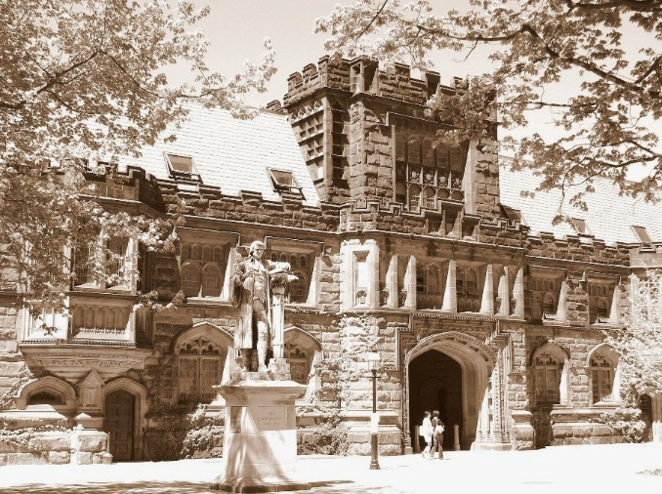Chartered in 1746 as the College of New Jersey — the name by which it was known for 150 years — Princeton University was British North America's fourth college. Located in Elizabeth for one year and then in Newark for nine, the College of New Jersey moved to Princeton in 1756. It was housed in Nassau Hall, which was newly built on land donated by Nathaniel FitzRandolph. Nassau Hall contained the entire College for nearly half a century.

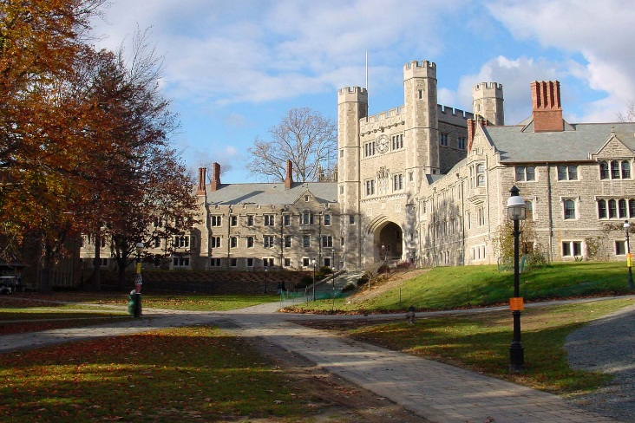In 1896, when expanded program offerings brought the College university status, the College of New Jersey was officially renamed Princeton University in honour of its host community of Princeton. Four years later, in 1900, the Graduate School was established.

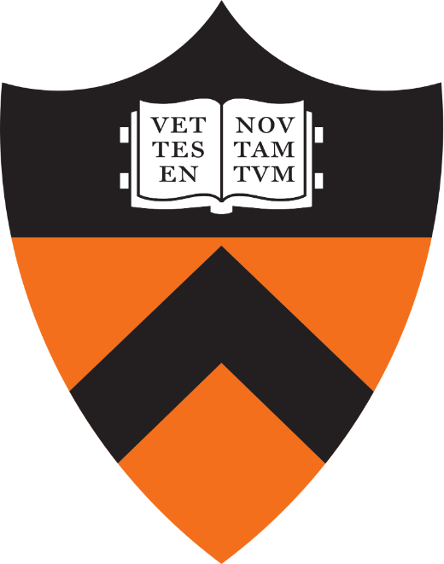Princeton is one of the smallest of the nation's leading research universities. Its size permits close interaction among students and faculty members in settings ranging from introductory courses to senior theses. An interdisciplinary approach is key to the curriculum at Princeton.

## University Flag, Shield, and Motto

The flag of the University displays the school's shield and motto. The open book is inscribed with "Vet. Nov. Testamentum" (Old and New Testament). The motto, "Dei Sub Numine Viget," translates as "Under the Protection of God She Flourishes."

The orange of the flag stands for William III of Orange, Prince of Nassau, and King of England. Black was first used as Princeton's other colour in 1867, when the sophomore baseball team used black ink to write class numerals on their orange ribbons.

## Campus

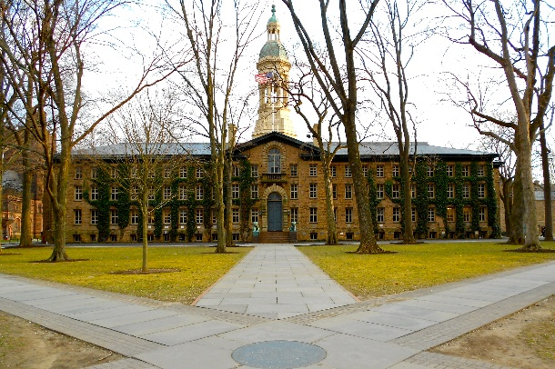The main campus sits on about 500 acres (2.0 km2) in Princeton. In 2011, the main campus was named by Travel+Leisure as one of the most beautiful in the United States.

The first building on campus was Nassau Hall, completed in 1756, and situated on the northern edge of campus facing Nassau Street. The campus expanded steadily around Nassau Hall during the early and middle 19th century. The McCosh presidency (1868–88) saw the construction of a number of buildings in the High Victorian Gothic and Romanesque Revival styles. At the end of the 19th century, Princeton adopted the Collegiate Gothic style for which it is known today. A flurry of construction in the 1960s produced a number of new buildings on the south side of the main campus.

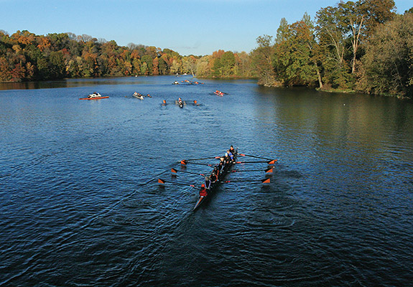 At the southern edge of the campus is Lake Carnegie named for Andrew Carnegie. Carnegie financed the lake's construction in 1906 at the behest of a friend who was a Princeton alumnus. Carnegie hoped the opportunity to take up rowing would inspire Princeton students to forsake football, which he considered "not gentlemanly." The Shea Rowing Centre on the lake's shore continues to serve as the headquarters for Princeton rowing.

## Cost and Financial Aid

*The estimated cost of attendance for 2016-17*

|  |  |
| --- | --- |
| Tuition | $45,150 |
| Room charge | $8,285 |
| Board rate | $6,435 |
| Estimated miscellaneous expenses | $3,550 |
| **TOTAL** | **$63,420** |

Admission to Princeton is need-blind for all applicants, including international students.

The usual order of assigning assistance is:

* external scholarships that are awarded to the student (such as National

Merit or local community scholarships);

* a campus job;
* Princeton grant funds.

## Athletics

Princeton supports organized athletics at three levels: varsity intercollegiate, club intercollegiate, and intramural.

Princeton's colours are orange and black. The school's athletes are known as *Tigers*, and the mascot is a tiger. The Princeton administration considered naming the mascot in 2007, but the effort was dropped in the face of alumni opposition.

Princeton is an NCAA Division I school. Its athletic conference is the Ivy League. Princeton hosts 38 men's and women's varsity sports. The largest varsity sport is rowing, with almost 150 athletes.

## Famous Alumni

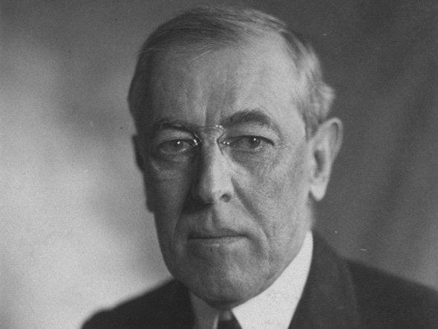*Woodrow Wilson*

Woodrow Wilson, the 28th president of the United States, graduated from Princeton in 1879 after spending his freshman year at Davidson College in North Carolina. He went on to study law at the University of Virginia and earn his doctorate at John Hopkins University. He became the president of Princeton from 1902 to 1910. The School of Public and International Affairs is named after him.

*Steve Forbes*

Steve Forbes is the president and CEO of Forbes, Inc. and editor-in-chief of Forbes magazine.

Forbes was also a Republican candidate for the nomination of U.S. president in 1996 and 2000.

The business magnate began his career in publishing as a researcher for Forbes magazine, which at the time was run by his father, Malcom S. Forbes, Sr. Steve took over the publishing empire after the death of his father in 1990.

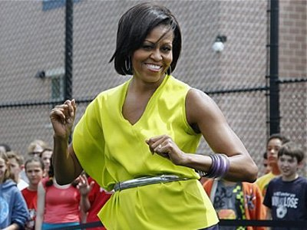*Michelle Obama*

First Lady Michelle Obama was actually discouraged from applying to Princeton by her high school advisors. In 1985, she graduated with a B.A. in sociology and minor in African American studies.

She went on to Harvard Law School and met a summer intern name Barack Obama during her first job as an associate at the law firm Sidley Austin.